**HR Assistant**

**Introduction**

The Job of a Human Resources Employee is hard work, especially when it comes to handle hundreds or thousands of Job Applications.

Often, the CVs are coming in unstructured formats, or also as Website Links. Keeping these data in order and prioritise interesting job applications can be difficult.

A bluemix application with leveraging IBM Watson services can help:

* Using the [Tone Analysier](http://www.ibm.com/smarterplanet/us/en/ibmwatson/developercloud/tone-analyzer.html) to get the emotions of the cover letters
* Using [Personality Insights](http://www.ibm.com/smarterplanet/us/en/ibmwatson/developercloud/personality-insights.html) to get learn more of the applicant
* Using [A](http://www.ibm.com/smarterplanet/us/en/ibmwatson/developercloud/relationship-extraction.html)lchemy Language to get the keywords used in the text in jobs and jobapplications.

The Application will consist of these Parts:

* HR Employee: Setup Job Listings (simple)
* Applicant: Entering data by the job applicant
* HR Employee: Viewing the applications and applicant data. Report of IBM Watsons, Graphs, etc.

**Links**

Accesable via the url: https://hrassistant.eu-gb.mybluemix.net/hrassistant.nsf/login.xsp

Public GIT repository: https://github.com/flinden68/HR-Assistant

**Prerequists**

For this application we communcate with IBM Watson for analysises and Cloudant to store all the data.

To make it easy we use 2 OSGi plugins, which are available on public GIT repositories. In the repositories there are update sites to make the integration in the application possible.

* Cloudant Connector, which handle the operations with Cloudant. https://bitbucket.org/flinden68/cloudant-connector
* Jackson JSON Mapper, https://bitbucket.org/flinden68/jackson-json-mapper-plugin

**Authentication**

On the GB data center is the SSO service not available, so we created a small authenication layer, which can prevent spam bots to access the application

When you are accessing the application and you are not authenticated you are redirected to the login page

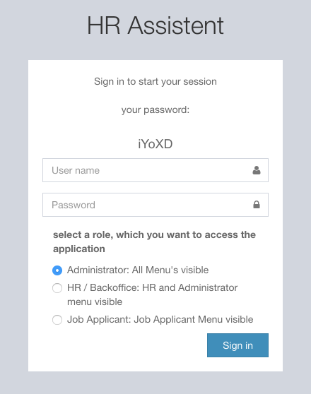

There you are required to provide a name, and fill in the temporary password, which is displayed at the top of the login screen.

When the password is correct you get access to the application.

The Username will be used in the application to display at the topbar, and when a CRUD operation has been performed.

If you select a role, you will see the application appropriate for that role. Make no choice if want to see all

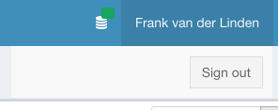

You see at the topbar on the right the user's name, when you click on the name, you get a menu, where you can sign out.

After sign out you are redirected to the login page.

**Configuration**

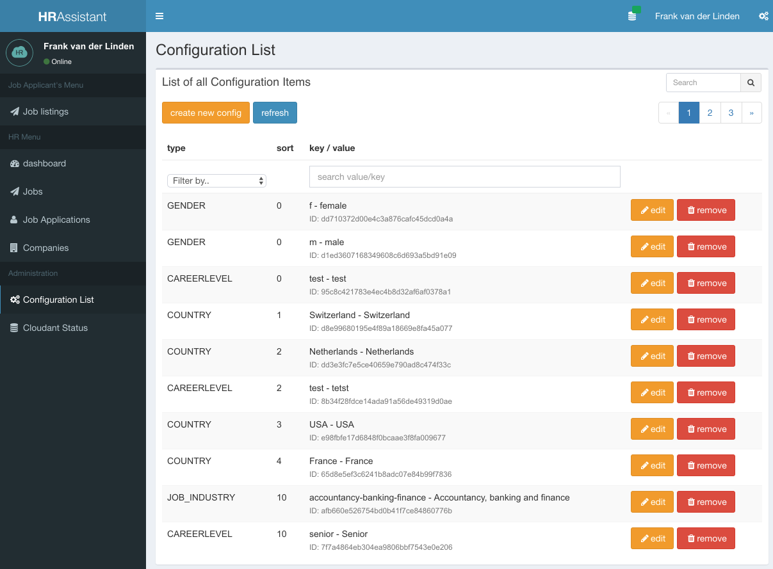

The application is highly configurable. Everything is managed in the Configuration section.

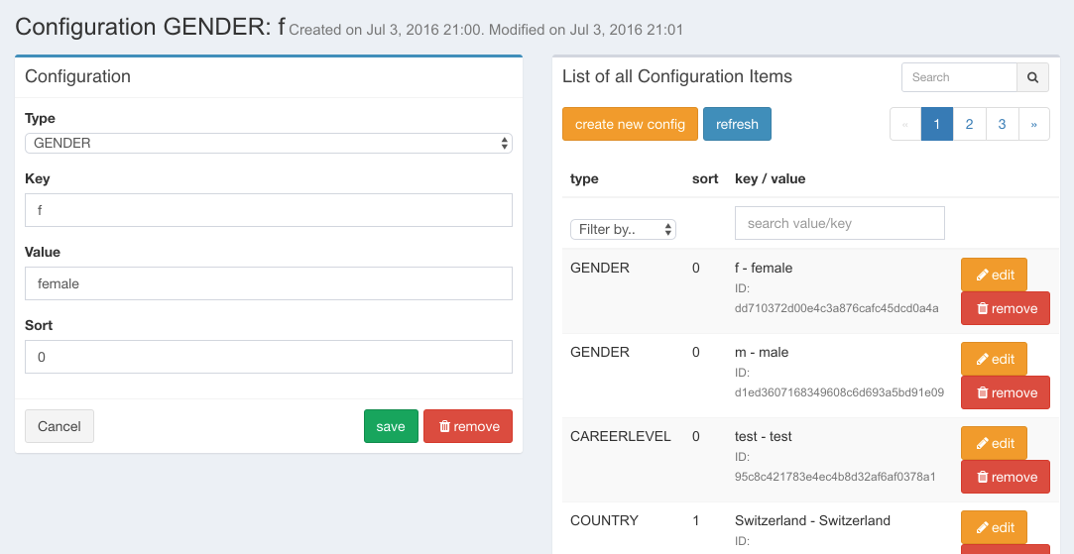

**Dashboard**

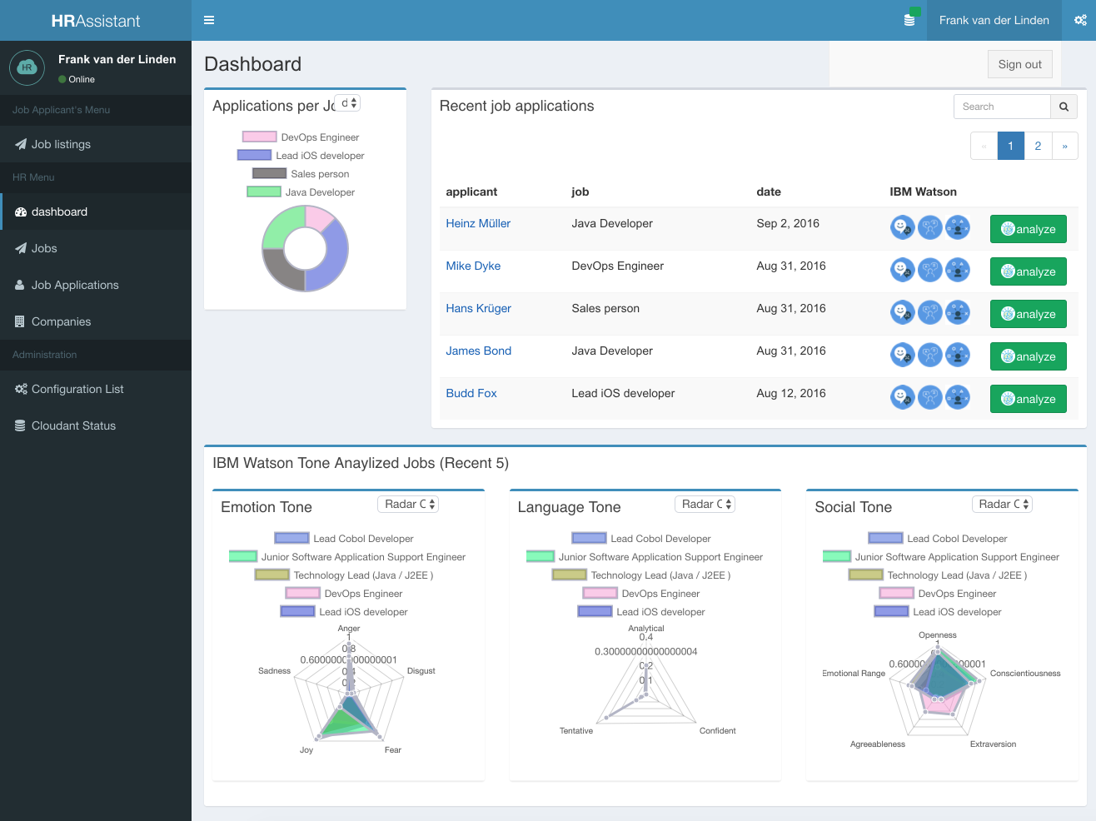

The above screenshot is the dashboard for the HR / Backoffice.

Below is the job listing, which is been seen by the Job Applicant. The joblisting is searchable and can be filtered on country.

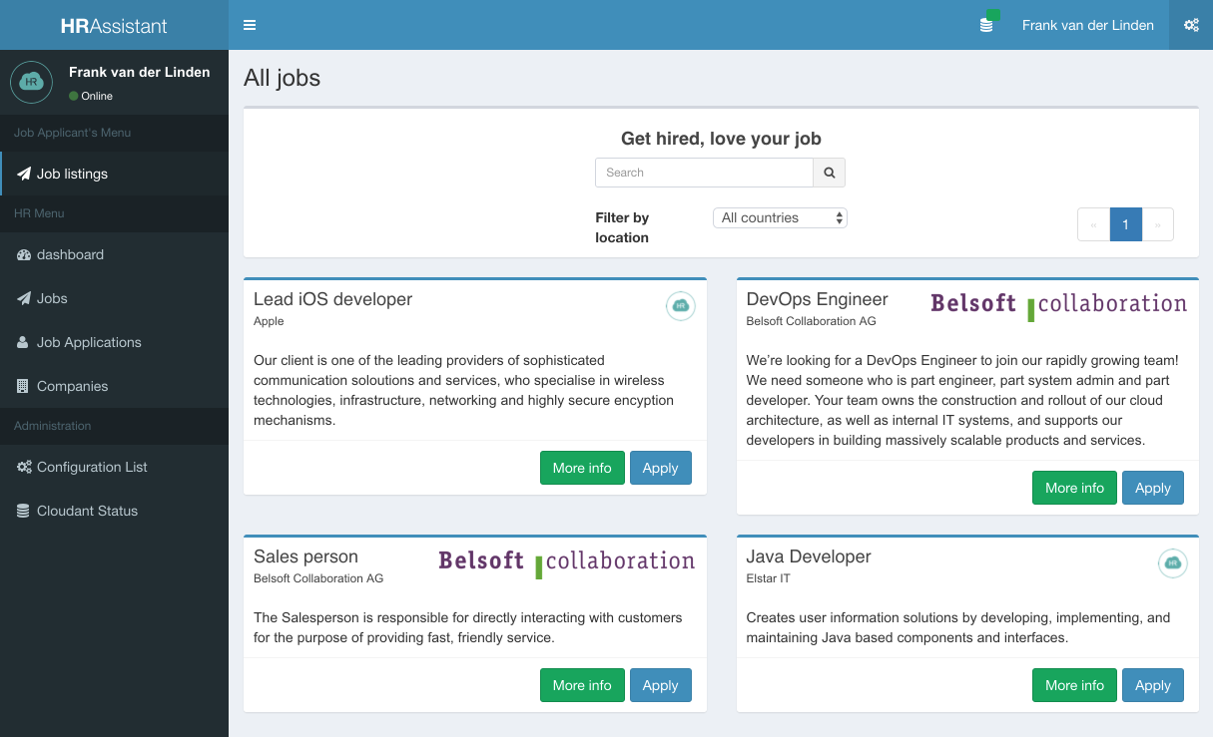

**Companies**

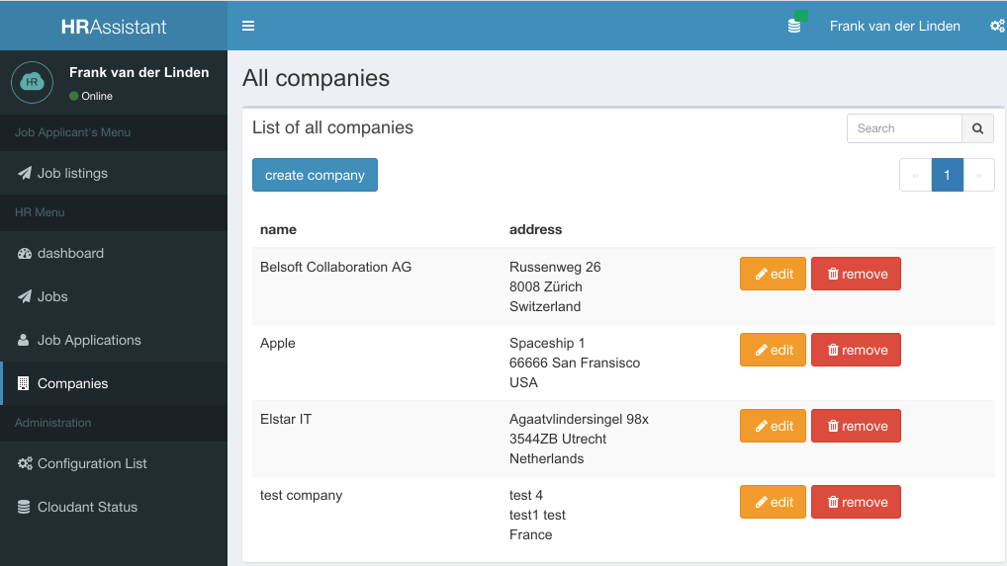

Above is an screenshot of the companies page, where you can create, edit and remove companies. If necessary the joblist can be searched.

When you open a company, to edit, you will see as below. There is also a possibility to upload a company logo, which is been shown in the joblisting

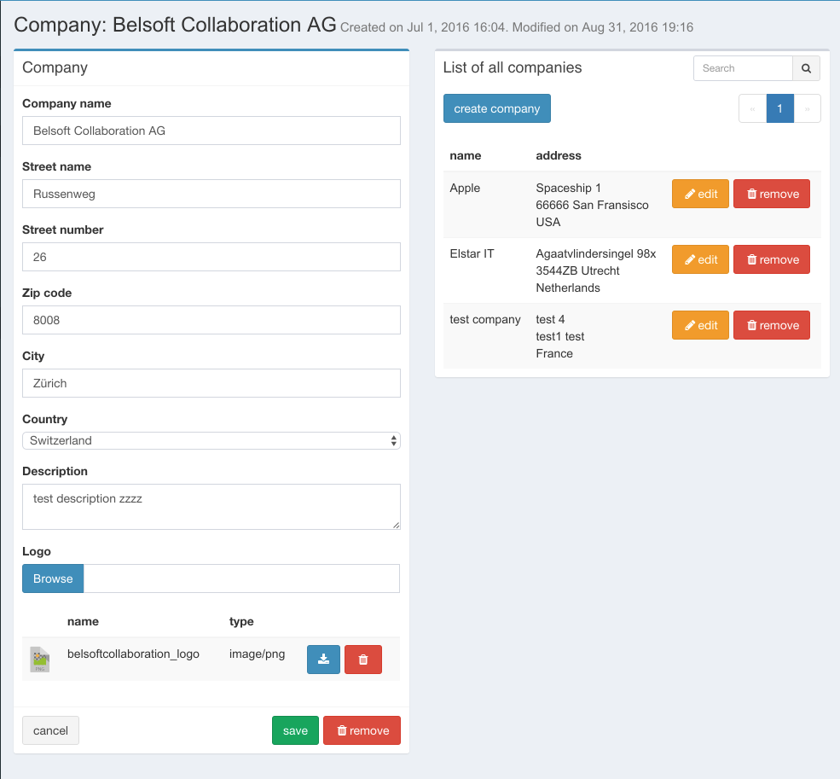

**Jobs**

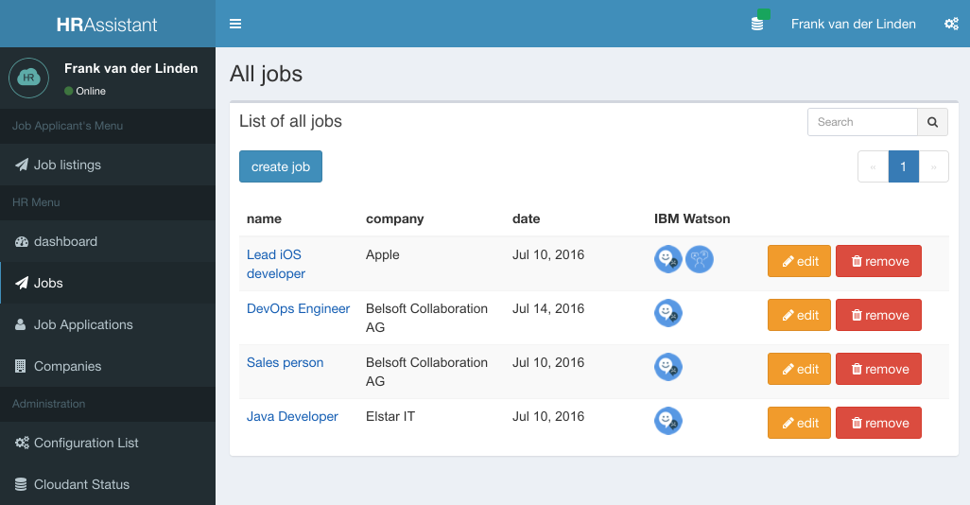

The Jobs menu item will show the list all jobs. This menu item is available for HR / Back office or Administrator only.

In the list is also shown if the job has been analyzed by IBM Watson.

When creating a job, a company should be choosen. In the description field can handle Rich text. When saved, you can choose if you want this job Analized immediatly by IBM Watson

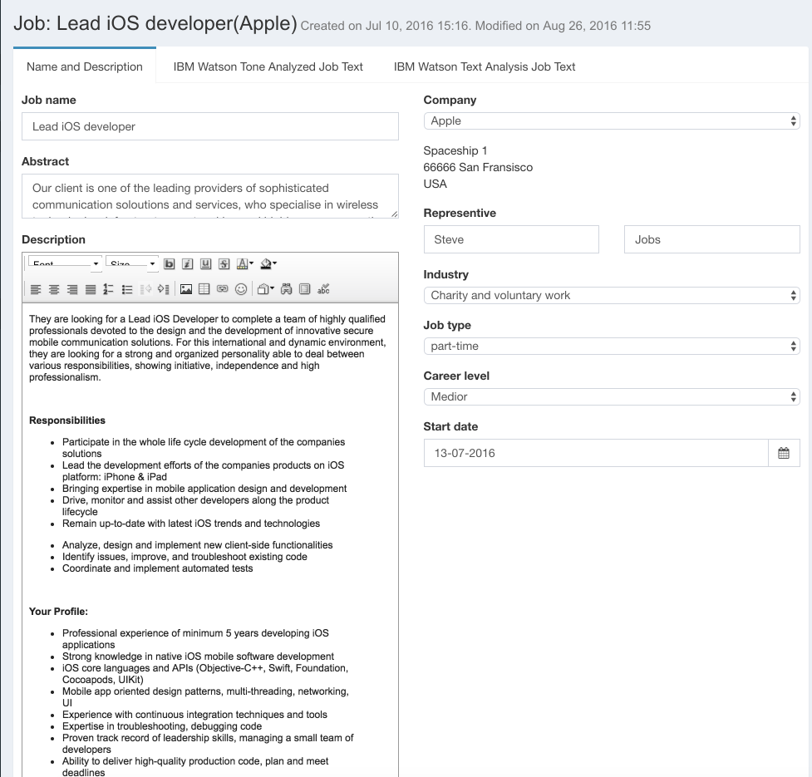

At the top, you can see the analysis of this Job. A tone and language keyword analysis are available

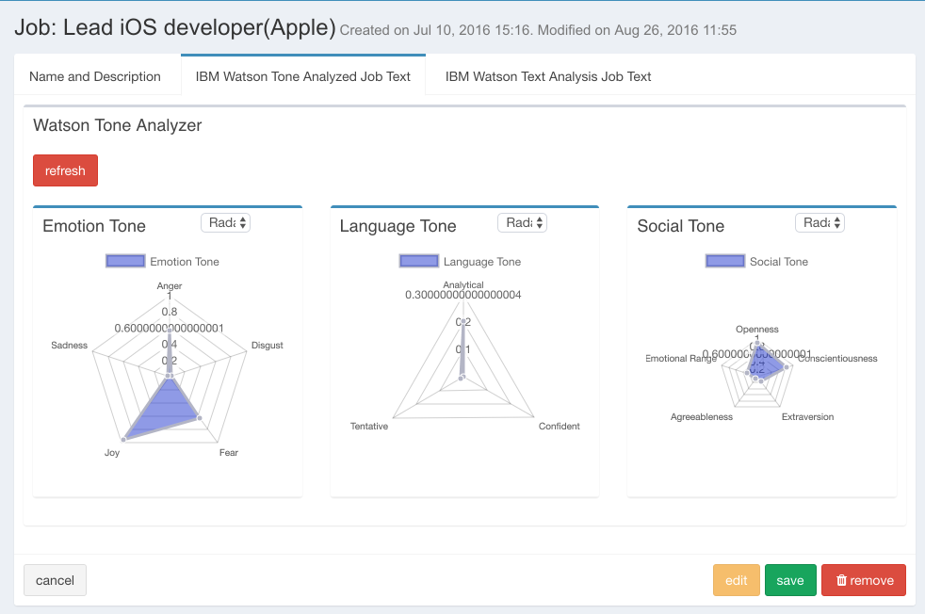

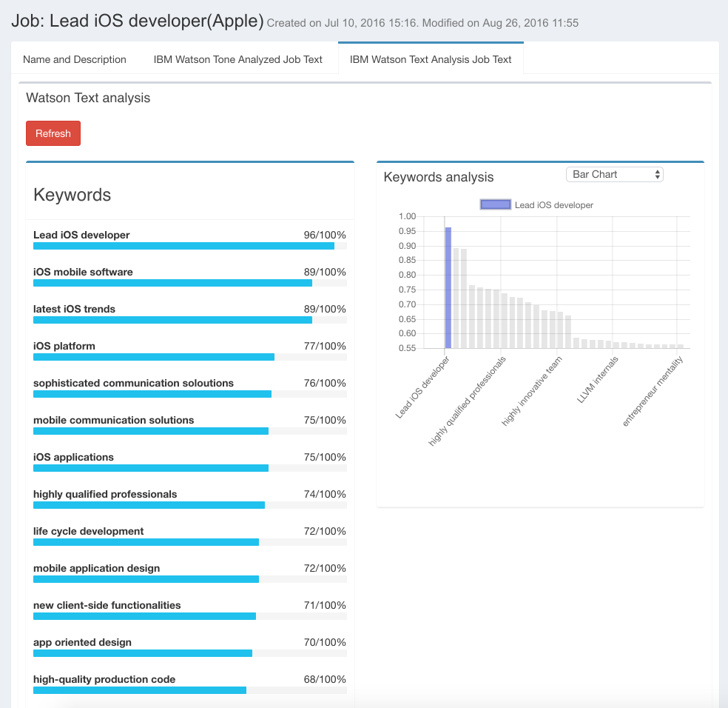

**Jobapplications**

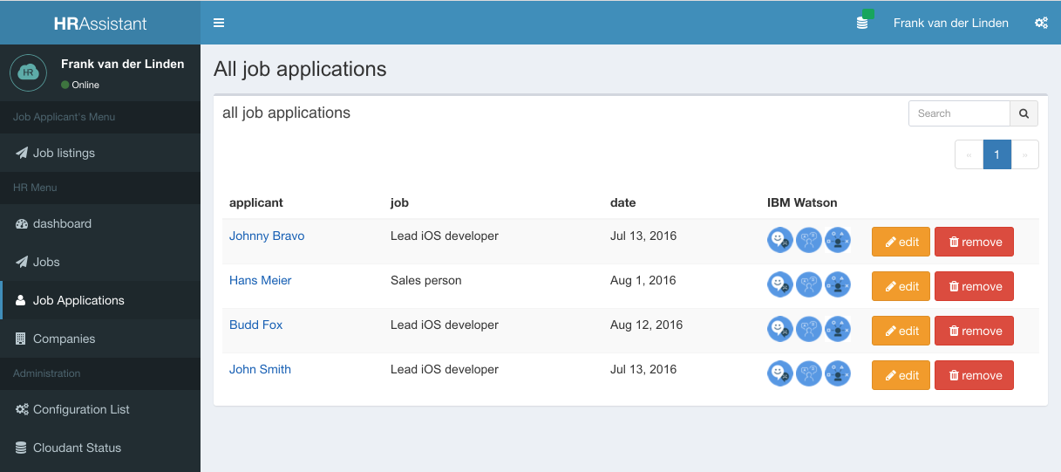

The job applications will be displayed in a list, but the appropriated will also been displayed on the Job page.

A Job Applicant can apply directly from the Job Listing page. The Job Applicant can fill in all the necessarry information and upload it's C.V.

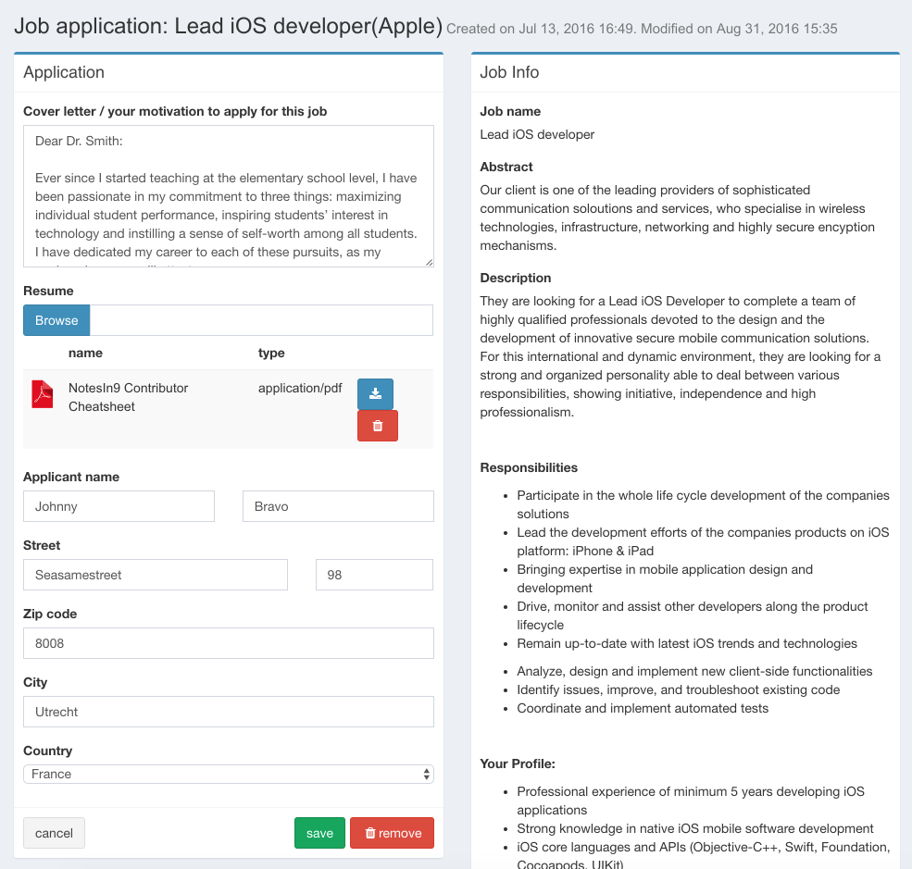

Everything will be analyzed by IBM Watson. A Tone, Personality and Language keyword will be available. And will be displayed in charts.

